**Lab – Reading and Writing Vector Data with OGR**

In this lab, you are going to practice on how to read and write vector data using OGR modules and Python. The goal is to read the parks shapefile (given to you via moodle) and write all the features that are **playgrounds** (notice this is one of the values in the **PARK_TYPE2** field) into a new shapefile. This new shapefile should only keep the attribute fields of **MBL** and **PARK_NAME**.

# parks.shp

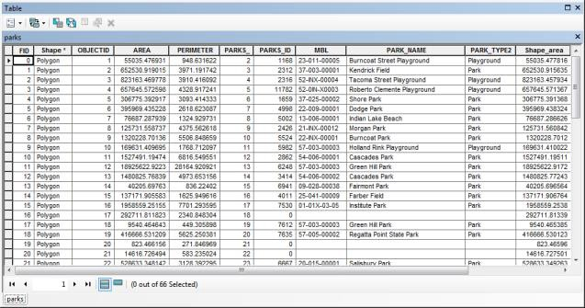



**The new shapefile:**

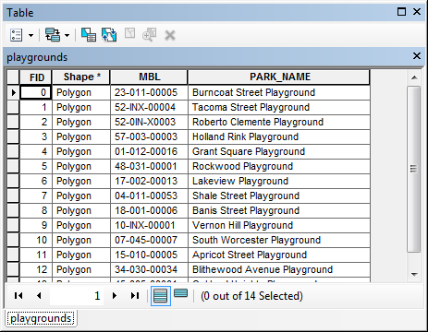



**Please submit your Python script with detailed comments. (20 points)**

1